**Module(HTML)-1**

**1). Are the HTML tags and elements the same thing?**

**Ans.**  No

**🡪 HTML Tag:-**

* html tags are enclosed within  **<Tag>**.
* html tags are defining the structure of html.

**Ex. :-**

<h1 > is the starting tag and </h1>is closing Tag

🡪**Elements:-**

* HTML element is defined by a starting tag
* HTML Element is usually consist of a start tag , close tag and content inserted between them.

**Ex. :-**

<h1>Heading content</h1>

-Heading content is element.

**2). What are tags and attributes in HTML?**

**Ans.**

**🡪 Tags:-**

* tags had also have attributes
* html tags are enclosed within angle braces **<Tag Name>**.

**Ex. :-**

<p> and </p> is html tag.

**🡪 Attributes:-**

* Attribute is used to define the characteristics of an HTML element.
* Attribute names and attribute values are case-insensitive

**Ex. :-**

    <a href="https://translate.google.com/"></a>

**3).What are void elements in HTML?**

**Ans.**

* Void elements only have a start tag; end tags must not be specified for void elements.
* Void elements cannot have content inside it.

**Tags:-**

* <br>
* <input>
* <link>
* <hr>
* <img>

**4).What are HTML Entities?**

**Ans.**

* Html entities are used to represent symbols.
* Html entities start with ‘&’.

|  |  |  |
| --- | --- | --- |
| Entities | Description | Value |
| &nbsp; | Space |  |
| &lt; | Lase-Thane | < |
| &gt; | Greater-Thane | > |
| &quot; | Double-quotation mark | “ |
| &apos; | Single-quotation mark | ‘ |
| &pound; | Pound | £ |
| &dollar; | Dollar | $ |
| &copy; | Copyright | © |
| &reg; | Registered | ® |

**5). What are different types of lists in HTML?**

**Ans.**

* **Types of lists in Html:-**

|  |  |
| --- | --- |
| List of Types | Define |
| <ol> | For Numbers |
| <ul> | For Symbols |
| <dl> | For Description |

**Ex. :-**

 <ol type="I">

        <li>one</li>

        <li>two</li>

    </ol>

    <ul type="square">

        <li>one</li>

        <li>two</li>

    </ul>

    <dl>

        <dt>Tea</dt>

        <dd>Hot</dd>

        <dd>cold</dd>

    </dl>

**Output:-**

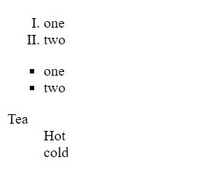

**6). What is the ‘class’ attribute in HTML?**

**Ans.**

* **‘Class’ attributes:-**
* The class attribute is used to associate an element with a style sheet and specifies the class of element.
* The class attribute is mostly used to point to a class in a style sheet.

**Ex. :-**

.intro {

color: blue;

}

.important {

color: green;

}

<h1 class="intro">Header 1</h1>

<p class="important">Note that this is an important paragraph.</p>

**Output:-**

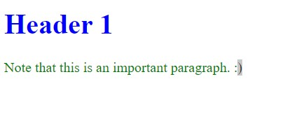

**7). What is the difference between the ‘id’ attribute and the ‘class’ attribute of HTML elements?**

**Ans.**

**🡪 ID:-**

* Id is unique.
* One element can have only one ID.
* Id can have an unlimited amount of Styles applied.

**Ex. :-**

#one{

            background-color: aquamarine;

        }

 <p id="one">rgefew</p>

**Output:-**



**🡪 Class:-**

* not unique
* You can use multiple classes on the same element.
* use the same Class on multiple elements.

**Ex. :-**

h1,h2{

               background-color: aqua;

        }

 <h1 class="one">cewet</h1>

    <h2 class="one">efwrgeth</h2>

**Output:-**



**8). What are the various formatting tags in HTML?**

**Ans.**

|  |  |
| --- | --- |
| Formatting Tags | Define |
| <b> | Bold |
| <i> | Italic |
| <u> | Underline |
| <sup> | Superscript |
| <sub> | Subscript |
| <del> | Delete |

**Ex. :-**

<b>name</b><br>

    <i>name</i><br>

    <u>Name</u><br>

    <sup>Lorem</sup><br>

    <sub>Lorem</sub><br>

    <del>Lorem</del><br>

**Output:-**

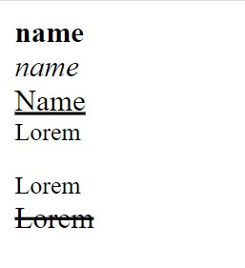

**9). How is Cell Padding different from Cell Spacing?**

**Ans.**

* **Cell Padding:-**
* Cell padding specifies the space between the border of a table cell and its contents.
* Cell padding sets the type attribute to cellpadding.
* Default value for cellpadding is 1.

**Ex. :-**

<table border="1" cellpadding="20">

        <tr>

            <th>1</th>

            <td>I</td>

        </tr>

        <tr>

            <th>2</th>

            <td>II</td>

        </tr>

        <tr>

            <th>3</th>

            <td>III</td>

        </tr>

        <tr>

            <th>4</th>

            <td>IV</t

        </tr>

    </table>

**Output:-**

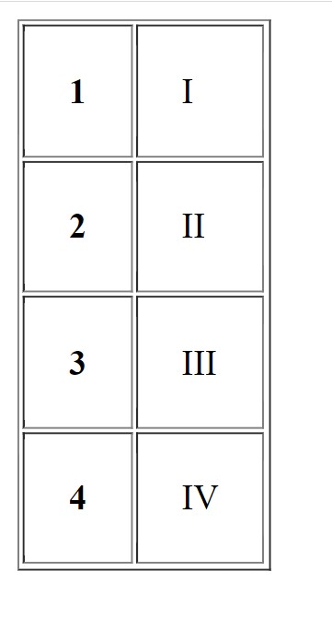

* **Cell Spacing:-**
* Cell spacing specifies the space between adjacent cells.
* Cell spacing sets the type attribute to cellspacing.
* Default value for cellspacing is 2.

**Ex. :-**

 <table border="1" cellspacing="20">

        <tr>

            <th>1</th>

            <td>I</td>

        </tr>

        <tr>

            <th>2</th>

            <td>II</td>

        </tr>

        <tr>

            <th>3</th>

            <td>III</td>

        </tr>

        <tr>

            <th>4</th>

            <td>IV</td>

        </tr>

    </table>

**Output:-**

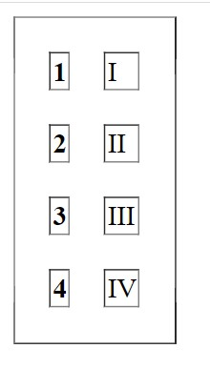

**10). How can we club two or more rows or columns into a single row or column in an HTML table?**

**Ans.**

* **Col-Span:-**
* merge two or more [table](https://www.computerhope.com/jargon/t/table.htm) cells in a [column](https://www.computerhope.com/jargon/c/column.htm) using the colspan**.**

**Ex. :-**

 <table border="1">

        <tr>

            <th colspan="2">1</th>

            <!-- <td>I</td> -->

        </tr>

        <tr>

            <th>2</th>

            <td>II</td>

        </tr>

        <tr>

            <th>3</th>

            <td>III</td>

        </tr>

        <tr>

            <th>4</th>

            <td>IV</td>

        </tr>

    </table>

**Output:-**

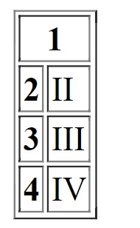

* **Row-Span:-**
* merge two or more [Row](https://www.computerhope.com/jargon/t/table.htm) cells using the rowspan**.**

**Ex. :-**

<table border="1">

        <tr>

            <th rowspan="3">1</th>

            <td>I</td>

        </tr>

        <tr>

            <!-- <th>2</th> -->

            <td>II</td>

        </tr>

        <tr>

            <!-- <th>3</th> -->

            <td>III</td>

        </tr>

        <tr>

            <th>4</th>

            <td>IV</td>

        </tr>

    </table>

**Output:-**

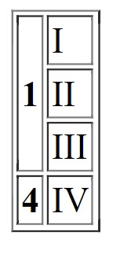

**11). What is the difference between a block-level element and an inline element?**

**Ans.**

**🡪Block-level element:-**

* Block-level element always starts on a new line
* Block-level element always takes up the full width
* The <p>, <h1>….<h6> and <div> are block-level element.

**Ex. :-**

<!DOCTYPE html>

<html lang="en">

<head>

    <meta charset="UTF-8">

    <meta http-equiv="X-UA-Compatible" content="IE=edge">

    <meta name="viewport" content="width=device-width, initial-scale=1.0">

    <title>new</title>

</head>

<body>

    <h1 style="background-color: bisque;">mann</h1>

</body>

</html>

**Output:-**



**🡪Inline-level element:-**

* An inline element does not start on a new line.
* An inline element only takes up as much width as necessary.
* The <i>,<u>,<b> and <span> are Inline level element.

**Ex. :-**

<!DOCTYPE html>

<html lang="en">

<head>

    <meta charset="UTF-8">

    <meta http-equiv="X-UA-Compatible" content="IE=edge">

    <meta name="viewport" content="width=device-width, initial-scale=1.0">

    <title>new</title>

</head>

<body>

 <b style="color: blue; background-color: brown;">Mann</b>

</body>

</html>

**Output:-**



**12). How to create a Hyperlink in HTML?**

**Ans.**

* Using <a> tag create the hyperlink.
* <a> tag has 3 attributes {_blank, _parent, _top}

**Ex. :-**

<!DOCTYPE html>

<html lang="en">

<head>

    <meta charset="UTF-8">

    <meta http-equiv="X-UA-Compatible" content="IE=edge">

    <meta name="viewport" content="width=device-width, initial-scale=1.0">

    <title>Document</title>

</head>

<body>

    <a href="https://maps.google.com/" target=”_blank”>new link</a>

</body>

</html>

**Output:-**



**13). What is the use of an iframe tag?**

**Ans.**

* Iframe tag is specifies an ‘inline frame’
* Inline frame is used to embed another document within the current HTML document.
* Iframe tag syntax is <iframe src=”link”>….</iframe>

**Ex. :-**

# <iframe width="560" height="315" src="https://www.youtube.com/embed/QkkoHAzjnUs" title="YouTube video player" frameborder="0" allow="accelerometer; autoplay; clipboard-write; encrypted-media; gyroscope; picture-in-picture; web-share" allowfullscreen></iframe>

**Output:-**



**14). What is the use of a span tag? Explain with example?**

**Ans.**

* <span> tag is used for grouping and applying styles to inline elements.
* change the language of a part of the text.
* change the color, font, background of a part of text.
* can be used to group elements for styling purposes

**Ex. :-**

 <p>Lorem ipsum <span style="color: brown;"> dolor sit amet, consectetur</span> elit.</p>

**Output:-**

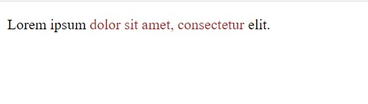

**15). How to insert a picture into a background image of a web page?**

**Ans.**

* Using <img src=”….”>tag you can insert the image in back-ground.

**Ex. :-**

 <img src="https://images.pexels.com/photos/516541/pexels-photo-516541.jpeg?auto=compress&cs=tinysrgb&w=600" alt="">

**Output:-**



**16). How are active links different from normal links?**

**Ans.**

**🡪Active Link:-**

* Active link is clickable link.

**Ex. :-**

 <a href="1. Img.html">Mann</a>

**Output:-**

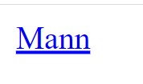

**🡪Normal Link:-**

* Normal link is non Clickable link.

**Ex. :-**

# <a href="" >Mann</a>

**Output:-**



**17).What are the different tags to separate sections of text?**

**Ans.**

|  |  |
| --- | --- |
| Tags | Define |
| <br> | Break the line before or after line |
| <p> | Define the paragraph. |
| <center> | Any content will be put in center |
| <div> | Division of a webpage. |

**18).What is SVG?**

**Ans.**

* SVG is scalable Vector Graphics.
* SVG is one type of Image.
* SVG is is an XML-based vector graphics.
* SVG image can be create and edit using vector graphics software.

**19) What is difference between HTML and XHTML?**

**Ans.**

|  |  |
| --- | --- |
| HTML | XHTML |
| Html stands for hypertext markup language. | Xhtml stands for Extensible hypertext markup language. |
| HTML is in Document file format. | XHTML has Markup Language as the file format. |
| Html document do not require validation. | Xhtml documents must be required properly validation. |
| all tags and attributes are do not have to be in lower case or higher case. | all tags and attribute are must be written in lowercase. |

**20). What are logical and physical tags in HTML?**

**Ans.**

**🡪Logical Tags:-**

* Logical tags are structure of the content.
* In logical tags <h1>…..<h6>, <p>, <ul>

**Ex. :-**

 <h1>prajapati</h1>

    <p>Param</p>

    <ul>Param</ul>

**Output:-**

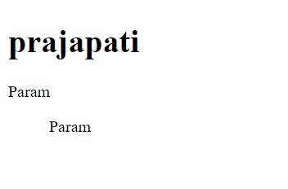

**🡪Physical Tags:-**

* Physical tag are Presentation of the Content.
* In Physical tags <b>,<strong>,<i>,<u>

**Ex. :-**

<b>Bold</b><br>

<strong>strong</strong><br>

<i>Lorem</i><br>

<u>Underline</u><br>

**Output:-**

